

Nomad System Configurations

1. December 2019

Version 2.0

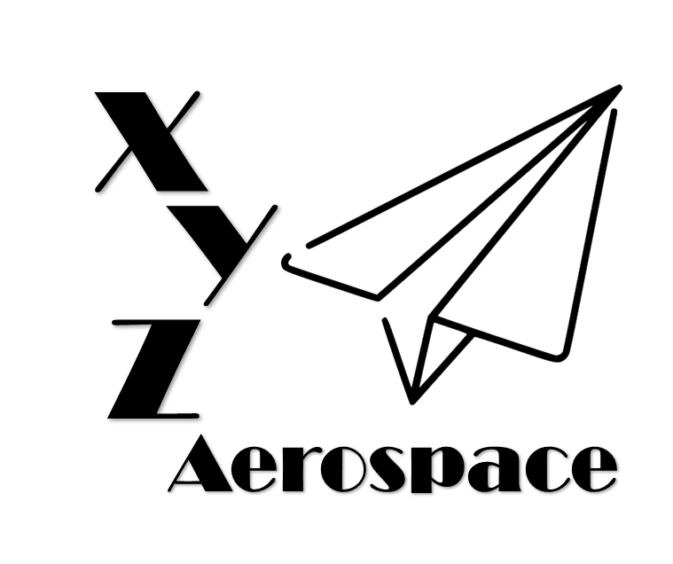

645 Colonel Glenn Blvd

Dayton, Ohio

DISCLAIMER: This document has been produced to support training and experimentation ONLY. It does not represent any system, real or planned. No United States Government resources were used to produce this document.

**THIS PAGE IS INTENTIONALLY BLANK**

Contents

1. Introduction 5

2. Overview 5

3. Configuration ID 5

4. Air System 6

4.1. Wanderer-Baseline: 6

4.2. Nomad-01: 6

4.3. Nomad-02: 7

5. Ground Systems: 7

5.1. Legacy: 7

5.2. DGCS v1: 8

5.3. DGCS v2: 8

**THIS PAGE IS INTENTIONALLY BLANK**

1. Introduction

In order to most efficiently meet the needs of the Nomad program, testing has been conducted in multiple phases. This included surrogate testing using the legacy Wanderer system prior to the construction of the first Nomad versions. This testing process has resulted in test data associated with multiple physical configurations of the Nomad system. This document describes each physical configuration, along with the differences between the configurations.

1. Overview

The Nomad system is versioned primarily in two components: Air System and Ground System. The Air System includes the Air Vehicle and Payloads, while the Ground System includes the Ground Control Station. Currently, there are three (3) versions each of Air System and Ground System represented within the Nomad testing artifacts:

* Air System
  + Wanderer-Baseline
  + Nomad-01
  + Nomad-02
* Ground System
  + Legacy
  + Deployable Ground Control Station (DGCS) v1
  + DGCS v2

The final configuration proposed for the OTSS-E program consists of the Nomad-02 Air System and the DGCS v2 Ground System. The test program was deliberately executed to ensure that for each test all relevant physical parameters were representative of the final configuration. Where necessary, test points were re-executed to ensure that the artifacts represented the performance of the final configuration.

1. Configuration ID

Each combination of Air System and Ground System is represented by a unique identifier. The identifiers used are:

|  |  |  |
| --- | --- | --- |
| Configuration ID | Air System | Ground System |
| Wanderer-01-01 | Wanderer-Baseline | Legacy |
| Nomad-01-01 | Nomad-01 | Legacy |
| Nomad-01-02 | Nomad-01 | DGCS v1 |
| Nomad-02-02 | Nomad-02 | DGCS v1 |
| Nomad-02-03 | Nomad-02 | DGCS v2 |

1. Air System
   1. Wanderer-Baseline:

The commercially successful Wanderer air vehicle was designed to be modular and extremely flexible. Consequently, there have been many Wanderer physical configurations deployed and operational. To support this flexibility, XYZ developed a ‘standard’ physical configuration utilized for test and certification called the Wanderer-Baseline. This configuration includes all standard equipment, including the basic structure, power plant, control software/hardware, control link, and electrical system. Baseline does not include functional payloads; rather, it includes test instrumentation that is tailored for certification test objectives. To ensure representative testing, the Baseline is ballasted to certified mass properties. The Baseline configuration is considered to be fully representative of the final Nomad air vehicle flight operations, including flight performance, stability, handling, and reliability.

|  |  |  |  |
| --- | --- | --- | --- |
|  | Minimum | Nominal | Maximum |
| Weight (lbs) | 24.0 | 27.0 | 30.0 |
| Xcg (in) | -2.0 | 0.0 | 2.0 |
| YCg (in) | -2.0 | 0.0 | 2.0 |
| ZCg (in) | -3.0 | 2.0 | 4.0 |

* 1. Nomad-01:

During the early Nomad concept refinement phase, several technical areas were identified for high priority air vehicle development. The two highest priority development areas were implementing a domestic flight control system and developing jam resistant navigation capability. After significant effort, XYZ developed a form, fit, function replacement for the Flight Control System (FCS). During the test program, XYZ demonstrated that the Domestic FCS (DFCS) is functionally identical to the legacy FCS in operation including identical performance within the same system mass properties and flight envelope. Nomad-01 also implemented an updated Navigation Subsystem, including upgraded Inertial Navigation System (INS) with reduced drift and a Global Positioning System (GPS) module with limited jam resistance. Note that the allowable mass properties have been lowered to limit the testing/analysis burden for the OTSS-E program. Because the FCS upgrade required regression analysis, limiting the design envelope enabled the system to be designed much faster. This restriction served to ensure that replicating the flight control logic represented a conservative approach.

In addition to Air Vehicle improvements, Nomad-01 represented the first installation of the OTSS-E payloads. These included the Nomad mission computer, payload datalink and initial Full Motion Video (FMV) system. The initial FMV system consisted of both the day (optical) and night (low light optical) cameras simultaneously installed in the FMV turret. Testing showed that the FMV system did not meet requirements, so it is not considered to be representative of the final Nomad configuration. Nomad-01 integrated the first release of the Nomad mission software, including the autonomy capability which is representative of the final Nomad system. The wide area camera was not integrated, but shape representative mass model was installed to ensure mass properties were within tolerance.

|  |  |  |  |
| --- | --- | --- | --- |
|  | Minimum | Nominal | Maximum |
| Weight (lbs) | 26.0 | 27.2 | 28.0 |
| Xcg (in) | -1.0 | 0.78 | 1.0 |
| YCg (in) | -1.0 | 0.12 | 1.0 |
| ZCg (in) | -1.0 | 1.21 | 3.0 |

* 1. Nomad-02:

The final Nomad Air System configuration incorporates significant improvements to the Payload subsystem. These include an updated FMV system with higher performance, as well as the Wide Area Camera system. The updated FMV system dramatically changes how the FMV capability operates. Testing showed that integrating day and night sensors into a single turret caused significant limitations to both sensors with minimal added operational utility. With the low level of endurance expected by Nomad (approximately 30 minutes), the actual amount of cross-twilight operations is expected to be minimal. Nomad is still a day/night capability, as the new FMV is designed to enable switching from day to night operations within 6 minutes on the ground. The updated FMV turrets enable greatly increased sensor performance in all flight environments. Testing also showed improvements to the mounting of both the FMV and Wide Area camera systems, resulting in a slightly more forward (~0.5 inches) mounting location for both systems and a slightly higher (~0.75 inch) location for the FMV.

|  |  |  |  |
| --- | --- | --- | --- |
|  | Minimum | Nominal | Maximum |
| Weight | 26.0 | 27.0 | 28.0 |
| Xcg (in) | -1.0 | 0.90 | 1.0 |
| YCg (in) | -1.0 | 0.12 | 1.0 |
| ZCg (in) | -1.0 | 1.05 | 3.0 |

1. Ground Systems:
   1. Legacy:

The Legacy Wanderer ground system is extremely different from the Nomad ground system. To facilitate maximum flexibility, the legacy system utilized a very minimal ground station, comprised of hand control capability sourced from commercial UAVs. This system was highly optimized for line of sight operations, operating at short range with no payload control. Control of payloads (including the link to the payload) was entirely provided by the end-user and is not representative of the Nomad system. Despite the lack of similarity to the Nomad GCS, the control link (including data flows) are identical between Legacy and Nomad. Because of this, the differences between ground stations do not affect the air vehicle behavior.

* 1. DGCS v1:

The Deployable Ground Control Station (DGCS) version 1 was the initial prototype Ground Station for Nomad. DGCS v1 implemented the Nomad specific pilot interface, as well as the mission control capability for Nomad Payloads. The DGCS v1 pilot interface included the final configuration for the control laptop and flight controller, along with the final pilot interface software. DGCS v1 also implemented the final payload link ground terminal (including radio, antenna and software).

While DGCS v1 was largely representative of the final Nomad configuration in capability, it was not packaged in a way that met OTSS-E requirements. DGCS v1 was a fixed capability that took significant effort to transport. The ground processing, radios, and power distribution system was not installed in the final configuration. Additionally, the systems were not ruggedized. Despite this, the payload capability is considered to be completely representative of the final configuration.

* 1. DGCS v2:

The final configuration of the Ground System was primarily focused on packing the DGCS v1 components into a rugged and transportable configuration. This included mounting all equipment into transit cases in a manner that isolated vibration, shock and environmental effects while facilitating airflow to critical components. Engineering was also required to provision for and route electrical wiring to all components, including a smaller form factor power distribution system and battery compared to DGCS v1. The modified battery has approximately 50% of the DGCS v1 life, but weights 35% of the previous variant. The final design weight of DGCS v2 is 98.5 pounds, including the air vehicle, single FMV turret and all GCS equipment.